Manager Training Guide

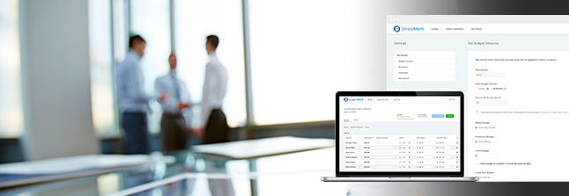

Table of Contents:
What is included in the Manager Training Guide? 3
Getting Started with SimplyMerit 3
Logging in and password recollection 3
My Org Page 4
My Team Page 6
Salary 6
Bonus 7
Equity 8
Approval Workflow 9
Additional Topics and Help 10

What is included in the Manager Training Guide?

This User Guide is a supplemental tool available for conducting internal training for managers on how to use SimplyMerit.

Getting Started with SimplyMerit

Logging in and password recollection

- Each manager will receive an email from support@simplymerit.com with an invitation to get started. This invitation will have a unique link that will allow them to create their account within SimplyMerit using a password of their choice.
- After the initial login, subsequent logins are done at https://app.simplymerit.com, which will take you to this screen.
TIP: You only get three login attempts before your account locks for 15 minutes! Reset your password after attempt two, or take a 15-minute break. We suggest getting coffee, checking email, or taking a walk!

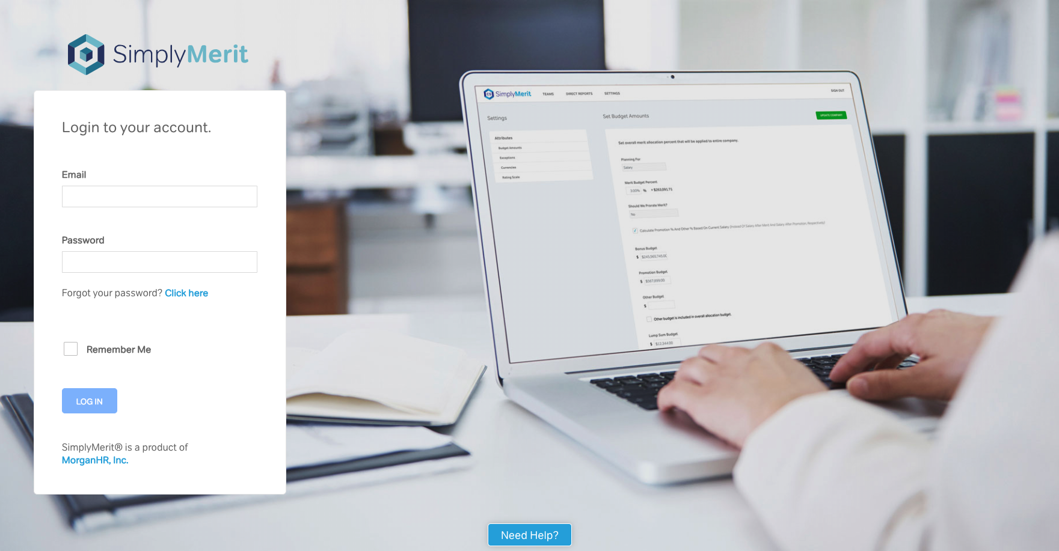
Enter your email address and password to login

- Tip: Be sure to emphasize that if their account locks, they must wait the full 15 minutes before they can either attempt to login or reset their password. They cannot reset their password if the account is locked.

My Org Page
A quick glance at the total amount allocated so far- updated in real time!

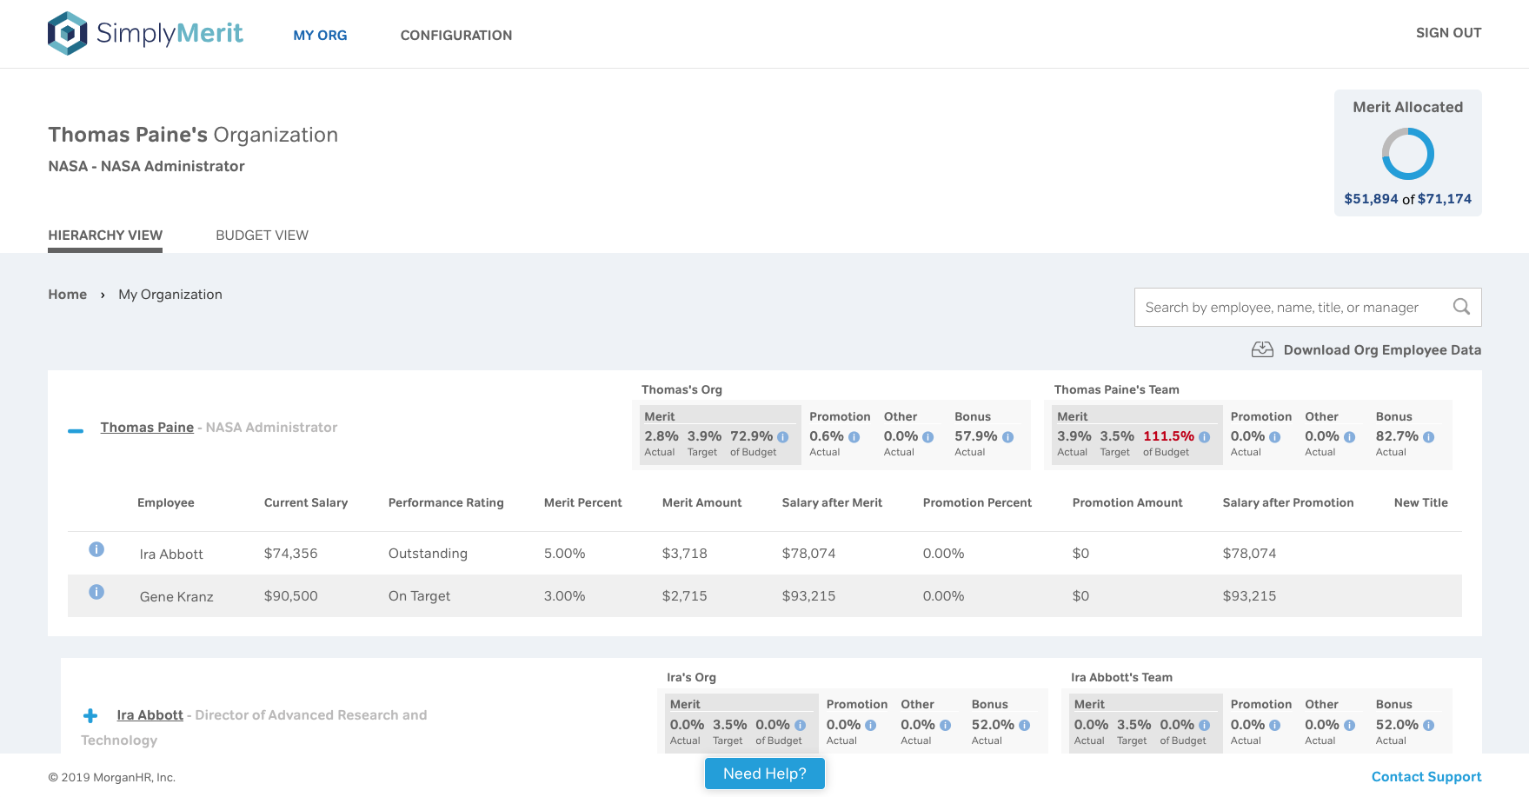
Navigate through the hierarchy by clicking the blue “+”

- My Org shows the manager’s span of control… direct and indirect reports
- Summary and detailed information all on one screen.
- Managers can navigate down their hierarchy expanding and contracting using the blue “ + / - “.
- Approvals are also managed from this single screen.
- The Merit Allocated graphic at the top right shows a quick “at a glance” total budget across the entire span of control and what’s been allocated thus far.
- The My Org | Budget View compresses the My Org view to just the summary boxes, which can be extremely helpful for HR and senior leaders to look for over-budget conditions

Direct Reports
Span of Control

- The two summary boxes next to each manager allows you to view key data points for that manager’s span of control as well as direct reports.
- Information is shown in both percentages as well as actual vs. budget amounts on the hover points.

My Team Page
- There are one to three tabs on the My Team page: Salary, Bonus, and/or Equity depending on your company’s specific configuration.

Salary
Actual vs. budget amount in both percentages and dollars!
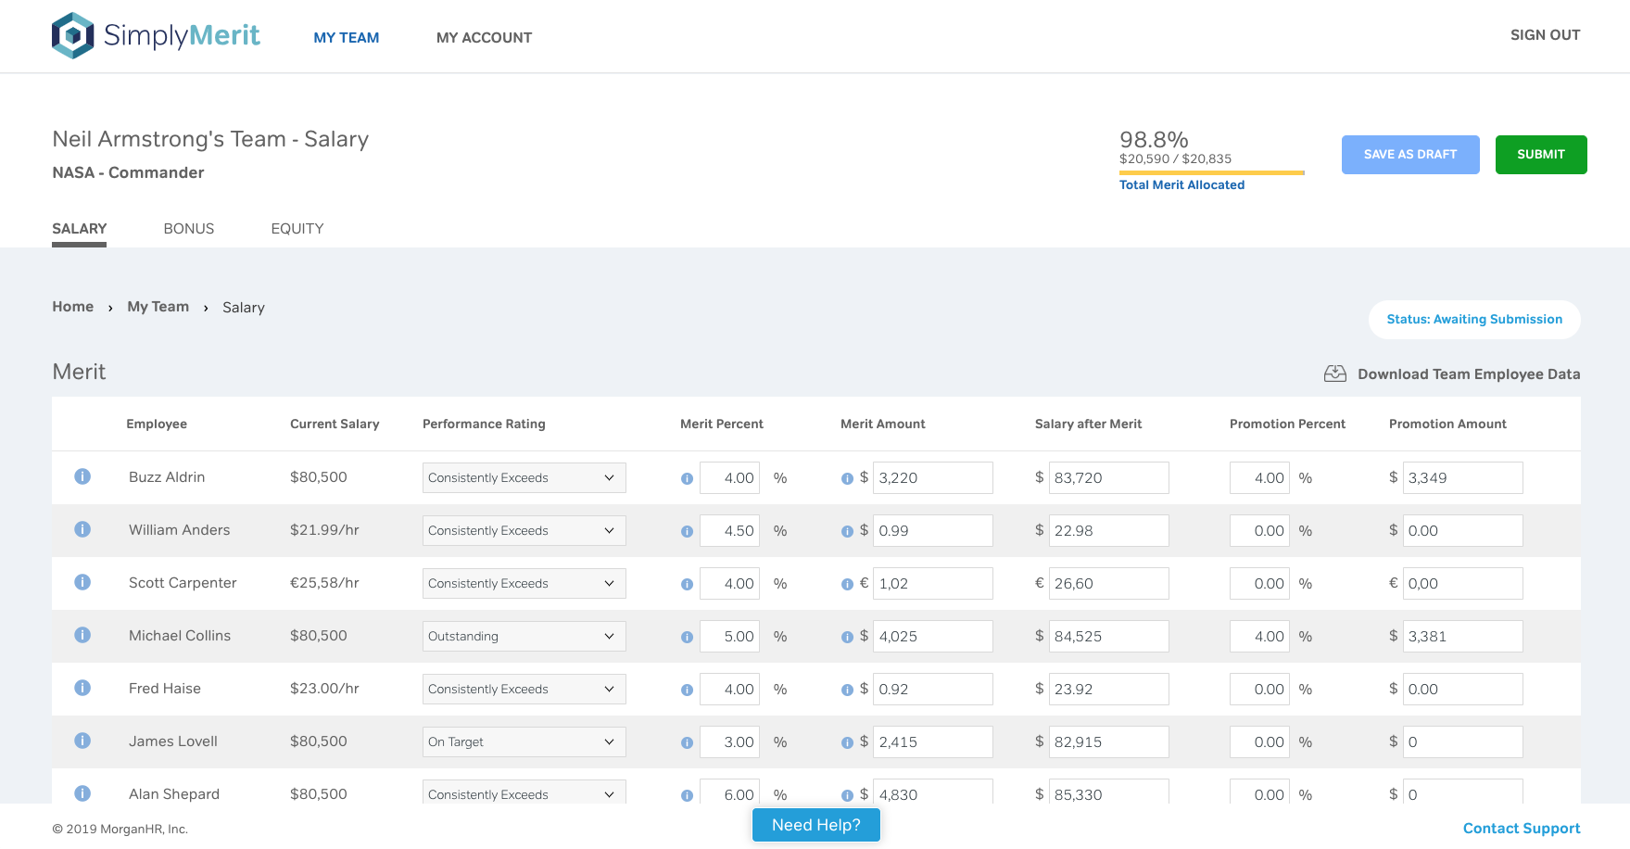
- The graphic at the top right shows actual vs. budget allocation of the merit budget. This is updated in real time as information is entered below.
- The two main action buttons on this screen are “Save as Draft” and “Submit”
- In the main body of the screen, working from left to right, clicking on the large informational “i” icon opens a window showing additional compensation information about the employee (market salary range, salary history, etc.)
- The Merit Percent, Merit Amount, and Salary after Merit fields all work in concert with one another. Entering or changing a value in one field, SimplyMerit calculates and adjusts the other two fields accordingly, along with the Total Merit Allocated graphic, all in real time.
  - There are two small “i” icons that are hover points. The first shows budgeted merit percent range and the second one shows budget merit amount.
- The next group of fields process Promotion request and function just like the merit fields.
- Same with the Other fields.
- Lump Sums may be added (typically for anyone who over the max of their comp range)
- Finally, comments may be entered or viewed by clicking on the comment bubble.
- The manager clicks Submit, SimplyMerit automatically sends an email notification to his/her manager that there’s an approval request pending. The email also includes a link back into SimplyMerit to review the request.
  - The requesting manager can continue to make changes to his/her team until it is approved, at which time he/she moves to view only.

Bonus

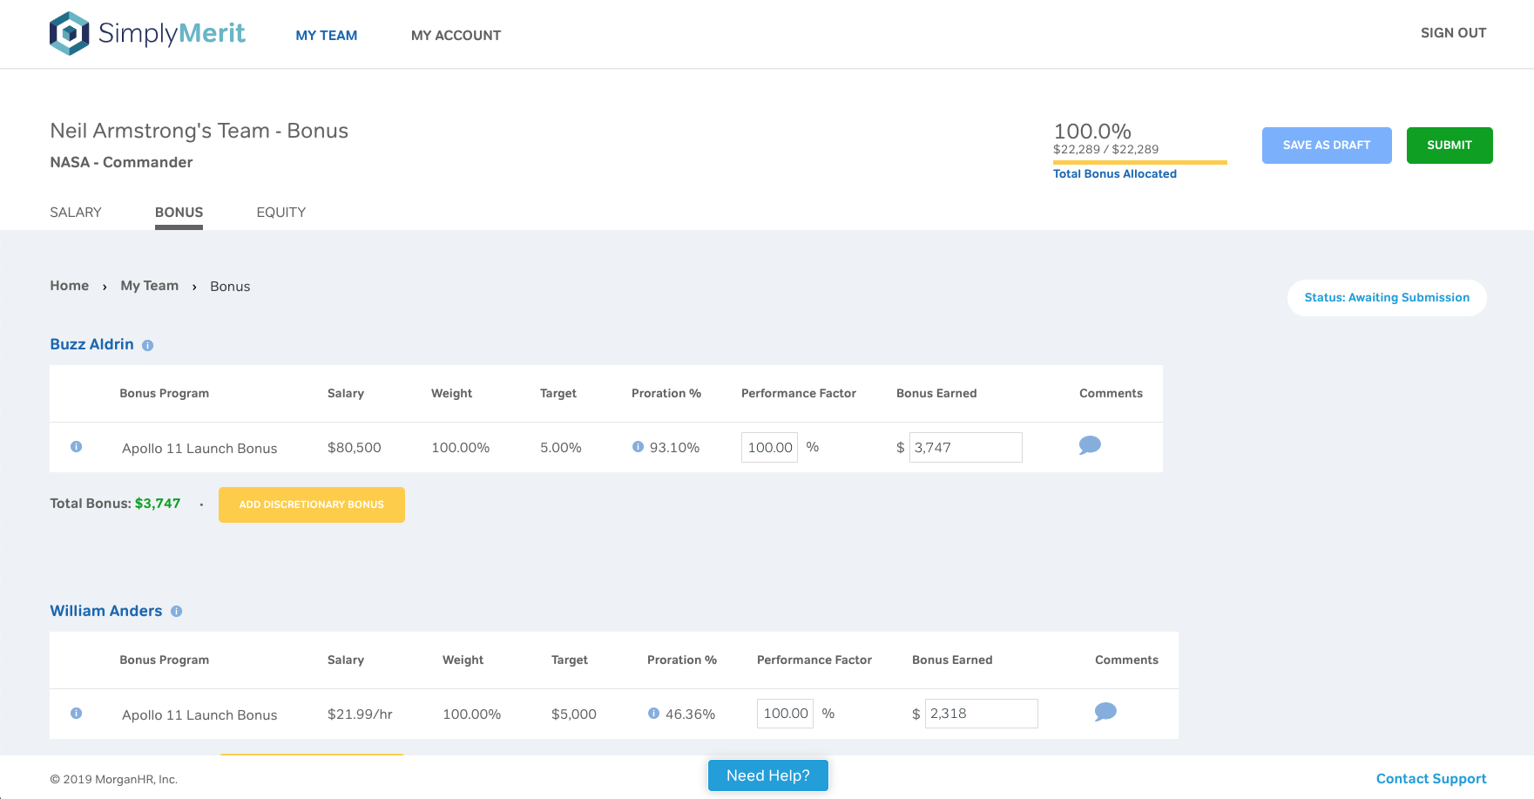
Enter the Performance Factor and SimplyMerit automatically calculates the Bonus Earned!

- The Bonus page has a similar structure to the Salary page with a Total Bonus Allocated graphic as well as Save and Submit buttons.
- Each Bonus program is detailed along with any proration calculations that may apply.
- Hover points show history as well as proration details
- Enter the Performance Factor, and SimplyMerit calculates the Bonus Earned amount and updates the Bonus Allocations at the top
- If present, the Add Discretionary Bonus button will allow you to request an additional discretionary bonus amount

Equity
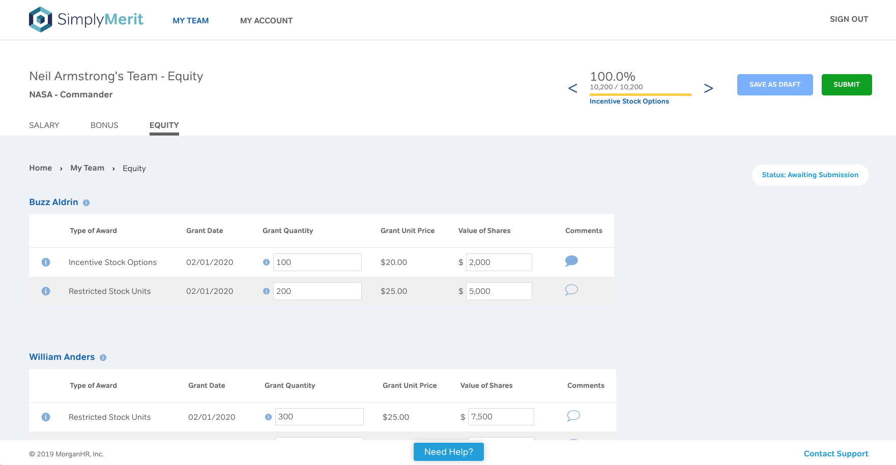
- The Equity page has a similar structure to the Bonus page with an actual vs. pool graphic as well as Save and Submit buttons.
- The Grant Quantity and Value of Shares fields work in concert with one another, where inputting a value in one field will cause SimplyMerit to calculate and adjust the other field accordingly. If known, the Grant Unit Price is set in the configuration steps by the HR Administrators.
- The small “i” icon next to the Grant Quantity field is a hover point that tells managers the target quantity of units for a specific Type of Award.
- The large “i” icon next to the Type of Award Field is a button that, when clicked, pops up a window with previous grant information for that employee.
- Once Salary, Bonus, and Equity adjustments have been submitted, you are done with this portion!

Approval Workflow
- Navigate back to the My Org page to review the approval process
- Approvals in SimplyMerit are done by the “one up” manager. Anyone up the chain from you can make modifications at any time, but it’s the “one up” manager who records the approval in the application

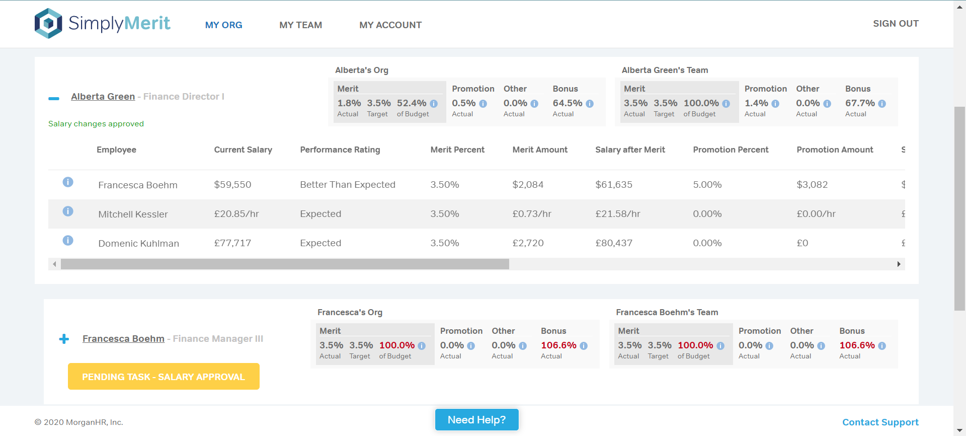
Click on a yellow “Pending Task” button and you’ll be taken to the Approval Screen!
- On the Approval Screen, Managers can review and either:
  - Modify: make changes and resave the submission
  - Approve: approve the submission
  - Reject: returns control back to the requesting manager
- Each of these actions will trigger an email back to the requesting manager
- (Navigate back to the My Org page if changes were made)

Additional Topics and Help

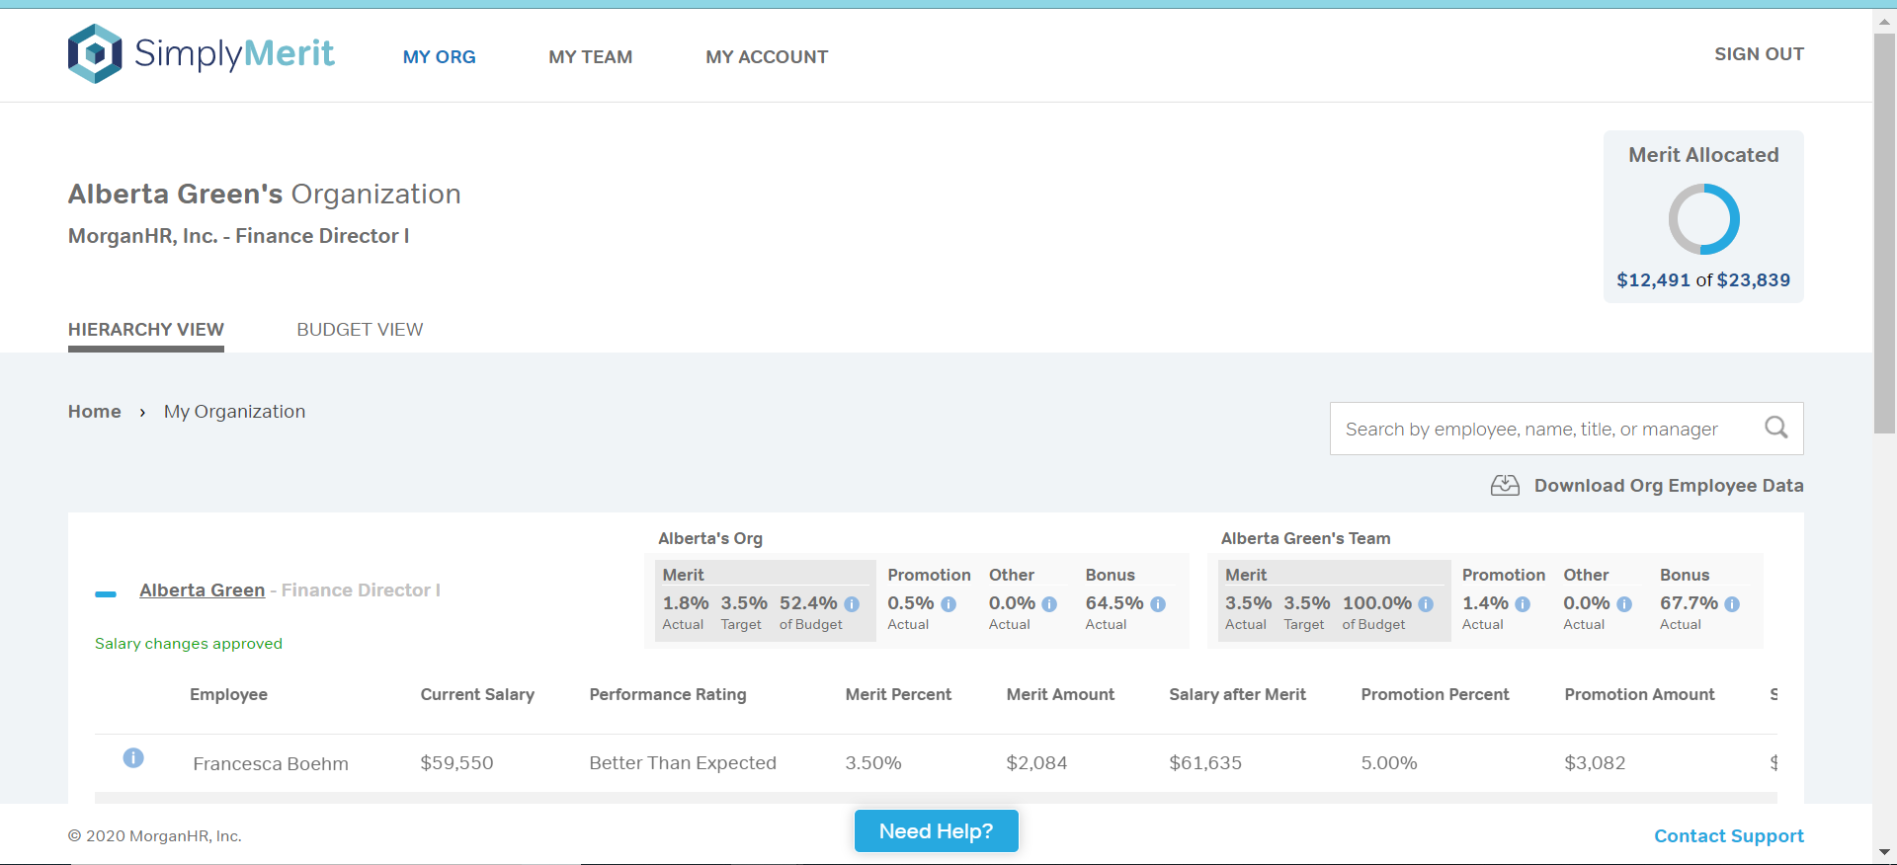
Download Org Employee Data to build an Excel report of what you see on the screen!

- The option to Download Org Employee Data allows managers to build an Excel report of the data shown on the screen
  - If the download file is too large, it will be moved to a background job and the download file may be retrieved from the My Account | Export page
- Integrated help is available by clicking the “Need Help?” button at the bottom of the screen. Clicking this button will open a side panel with page sensitive help topics
- Clicking the “Contact Support” link at the bottom of the screen will create an email to the primary HR Administrator.

